Determination of PFAS in ambient air samples by TD-GC-HR-Orbitrap-MS using a semi-targeted approach
Introduction
PFAS, or per- and polyfluoroalkyl substances, constitute a group of chemicals that have pervaded the environment globally due to their widespread use in various industrial and commercial applications. These persistent and bioaccumulative compounds have exhibited concerning effects on human health and the environment. To comprehend their occurrence and distribution, air samples are routinely collected and analysed. In this regard, ambient air samples play a crucial role as they provide insights into the contamination of PFAS in the atmosphere and their potential impacts on human health and ecosystems.
Experimental Part
In this experiment we want to use a semi-targeted approach to (semi)-quantify PFAS in ambient air samples. We will use TD-GC-HR-Orbitrap-MS to analyse air samples adsorbed on cartridges filled with Tenax TA.
Sample preparation:
Firstly, we way the GC-vial in our test gas source to determine the loss rate of our reference compound. Then, we will take a sample of a reference standard (1H,1H,2H,2HPerfluoro1-octanole) that we use for semi-quantitation. Therefore, you use the following setup:
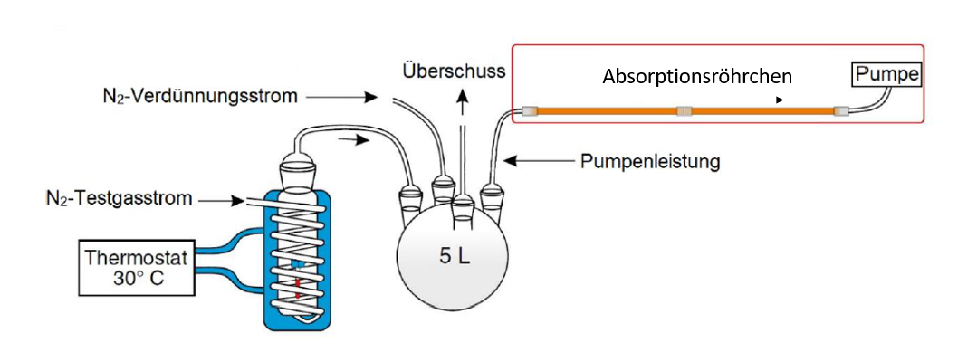
Use following parameters:
- Dilution flow scale mark 14; main flow scale mark 8
- Pump: 20 mL/min
- Duration: 1 min
Secondly, we will take a sample of ambient air. Use the following parameters:
- Flow: 445 mL/min
- Duration: 1 h
- After the sample is taken, dry the cartridge by passing nitrogen (50 mL/min; 5 min) through the cartridge

Measurement:
While you take the sample of ambient air, you can measure the cartridge with the reference standard. Use following desorption conditions:
- 1st desorption 5 min at 250 °C
- 2nd desorption 10 min at 180-220 °C
- Temperature of the cooling trap: -150 °C
Evaluation
Reference standard:
- Search for the reference compound by searching for the exact masses of specific PFAS fragments by creating XICs
- Compare the mass spectrum with the NIST library and save the mass spectrum and chromatogram
- Integrate the peak of the chosen XIC chromatogram & save all your files and peak areas
Ambient air sample:
- Search for the previously determined specific PFAS fragments und compare the mass spectra (don’t forget to save them)
- Try to assign the molecular identity of the PFAS found in your sample
- Integrate peaks that you claim to represent a PFAS compound
- Save all your files and peak areas

Colloquium
Please prepare following topics for the colloquium before the experiment:
- Prepare the exact masses of specific PFAS fragments
- Thermo desorption gas chromatography (TD-GC)
- Environmental relevance of PFAS
- Common analytical techniques used for PFAS analysis in the atmosphere
- High resolution Orbitrap mass spectrometry
- Targeted-analysis, semi-targeted analysis, non-targeted analysis
- Gas phase calibration setups
- SIM, XIC, TIC
Some more suggestions for your literature research:
- Movie: „Dark Waters“ (dt. “Vergiftete Wahrheit“) (just for fun if you are interested in PFAS involved in environmental scandals)
- Thorenz, U.R., Kundel, M., Müller, L. et al. Generation of standard gas mixtures of halogenated, aliphatic, and aromatic compounds and prediction of the individual output rates based on molecular formula and boiling point. Anal Bioanal Chem 404, 2177–2183 (2012). https://doi.org/10.1007/s00216-012-6202-5
Protocol
- Explain the environmental impact of PFAS
- Explain all the instruments used for the analysis
- Explain targeted, semi-targeted and non-targeted analysis. Which advantages and disadvantages do the different approaches have?
- Why do you need high resolution mass spectrometry for semi-targeted analysis?
- Show the chromatograms and mass spectra of the reference standard and the ambient air sample
- Try to assign specific fragments to the mass spectra and propose a structure for the PFAS compounds found in the ambient air sample (you can also argue with retention times)
- Calculate the amount of PFAS in your reference (unit reference: ng) and the ambient air sample and compare them to literature values (unit ambient air sample: ng/m³)
- How do the peak shapes of your PFAS look and why? How could you improve that?

To determine the mass on the cartridge of your reference standard you need the following equation:
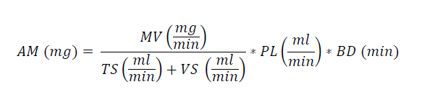
AM = analyte mass
MV = mass loss
TS = main flow
VS = dilution flow
PL = pump flow
BD = duration

